Ecology of Matagorda Island
Project Description: The San Antonio Bay Partnership (SABP) will work with the staff of the Texas Floating Classroom, Inc. (TFC) to provide transportation and educational services related to a one-day adult training entitled “Ecology of Matagorda Island.” The purpose of the training is to provide a hands-on environmental educational program for adult education groups (such as the Texas Master Naturalists) and other higher-education groups (such as the University of Houston – Victoria) that highlights the ecology of Matagorda Island and the adjacent bay system. The one-day training will consist of the three education modules described below:
Beach Ecology (approx. 2.5 hours): This educational unit includes an in-depth look at the beaches of Matagorda Island, the forces that shape them, and the organisms that live there. Participants will learn to perceive the ecological zones on the beach and to find and identify some characteristic animals that live in each zone. They will observe and discuss adaptations which permit survival on the beach and the food web which supports the unique assemblage of resident creatures. Finally, they will learn to appreciate some of the ways in which humans can disrupt the natural cycles of the beach. This module will include such activities as: burrow excavation, hand netting, sieving, and seining. Additional activities that could be added to this module include: conducting a beach profile, measuring longshore currents, and conducting a sand grain-size analysis.
Salt Marsh Ecology (approx. 2.5 hours): This educational unit includes an in-depth look at the salt marsh habitat on the bayside of Matagorda Island. Participants will examine the unique adaptations that many plants have evolved to help them survive in the fluctuating physical environment of the salt marsh. They will also examine the zonation and distribution of plants, and will find and identify commons residents of the marsh habitat. Finally, they will understand the important functions that salt marshes perform and learn to appreciate what habitat means to wildlife and why salt marshes need protection. This module will include such activities as: seining, sediment coring, sieving, hand netting, and quadrat measurements.
Bay Ecology (approx. 2 hours): While traveling to and from Port O’Connor and Matagorda Island aboard the TFC vessel, R/V Archimedes, participants will discover the plants and animals that inhabit the local bay system. Live plants and animals will be collected through shrimp and plankton trawls, and participants will have the opportunity to observe the specimens collected in touch tanks and under a microscope. Participants will examine and describe the organisms collected while they learn about adaptations, taxonomy, and ecology.
Participants will depart Port O’Connor aboard the R/V Archimedes and travel to the back-side of Matagorda Island where they will disembark from the boat at Sunday Beach. While onshore, participants will take part in both the Beach Ecology and Salt Marsh Ecology lessons. Participants will be required to walk to and from the backside of Matagorda Island and the Gulf beach area (approximately one quarter mile one-way). The Bay Ecology lesson will occur while participants are being transported to and from Matagorda Island. The maps below show the anticipated route between Port O’Connor and Sunday Beach, as well potential sites for the beach ecology and salt marsh ecology (referred to as “Bay Tidal Flat” in map) modules:
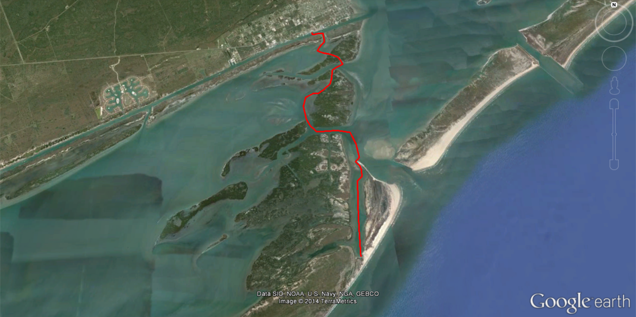
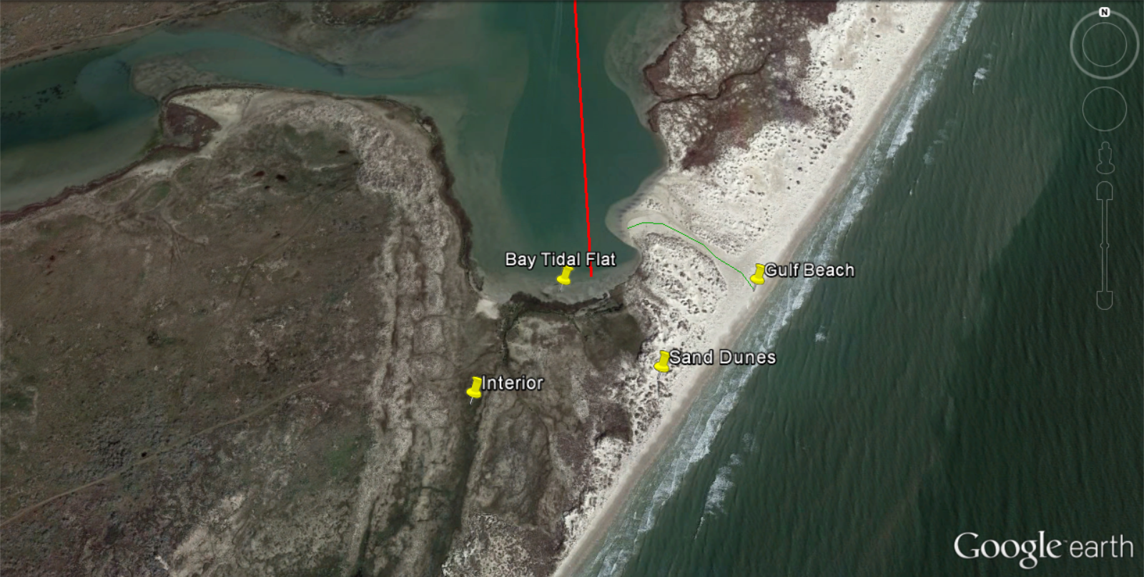

Kiersten Stanzel
San Antonio Bay Partnership
361-813-1401
kiersten.madden@gmail.com

